TUTORIAL 3

2.
- A) Convert the following SOP to POS

- Convert the following POS to SOP
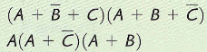

5.
6.
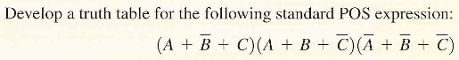
7
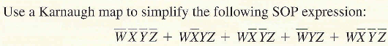

8. From the truth table find the minimum SOP expression by Karnaugh map
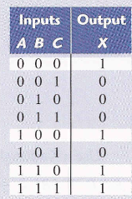
9.
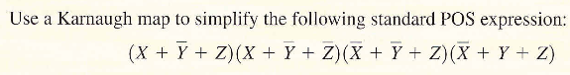
10.
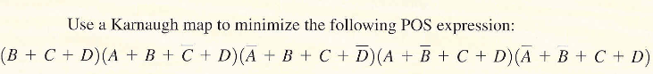
11.
